## 08 – Tuple/Set

**Ex. No. : 8.1 Date: 15/5/24**

**Register No.: 231801176 Name: Susmitha.M**

**Binary String**

Coders here is a simple task for you, Given string str. Your task is to check whether it is a binary string or not by using python set.

Examples:

Input: str = "01010101010" Output: Yes

Input: str = "REC101" Output: No

**For example:**

|  |  |
| --- | --- |
| **Input** | **Result** |
| 01010101010 | Yes |
| 010101 10101 | No |

# Program:

a = input() try:

c = int(a) print("Yes")

except:

print("No")

# Output:

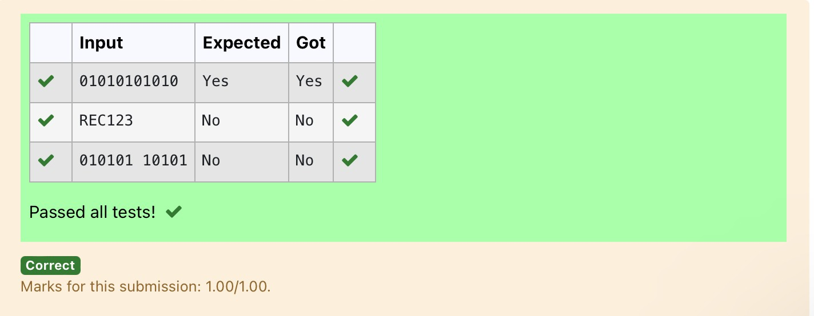

**Ex. No. : 8.2 Date: 15/5/24**

**Register No.: 231801176 Name: Susmitha.M**

## Check Pair

Given a tuple and a positive integer k, the task is to find the count of distinct pairs in the tuple whose sum is equal to **K**.

**Examples:**

**Input**: t = (5, 6, 5, 7, 7, 8 ), K = 13

**Output**: 2 Explanation:

Pairs with sum K( = 13) are {(5, 8), (6, 7), (6, 7)}.

Therefore, distinct pairs with sum K( = 13) are { (5, 8), (6, 7) }. Therefore, the required output is 2.

For example:

|  |  |
| --- | --- |
| Input | Result |
| 1,2,1,2,5  3 | 1 |
| 1,2  0 | 0 |

# Program:

t = input()

k = int(input()) a = t.split(",")

l = [int(x) for x in a] count = 0

x = set()

for i in range(len(l)):

for j in range(i + 1, len(l)): if l[i] + l[j] == k:

s = (l[i], l[j])

if s not in x and (l[j], l[i]) not in x: count += 1

x.add(s)

print(count)

# Output:

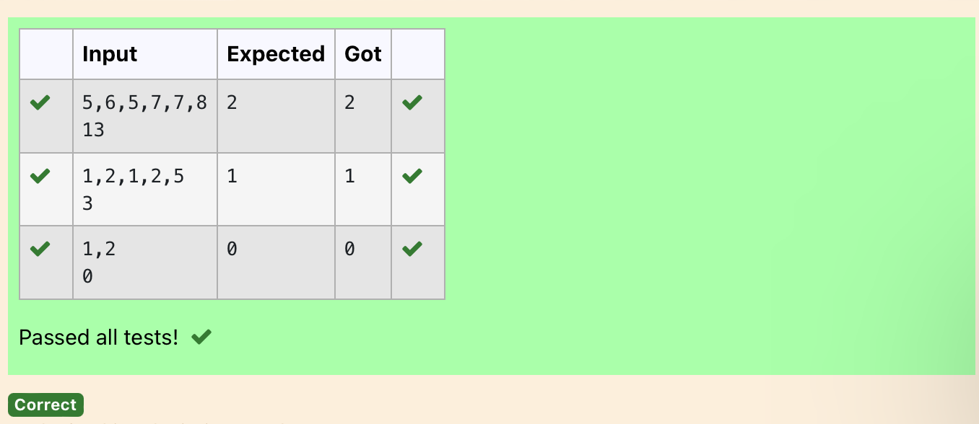

**Ex. No. : 8.3 Date: 15/5/24**

**Register No.: 231801176 Name: Susmitha.M**

**DNA Sequence**

The **DNA sequence** is composed of a series of nucleotides abbreviated as 'A', 'C', 'G', and 'T'.

For example, "ACGAATTCCG" is a **DNA sequence**.

When studying **DNA**, it is useful to identify repeated sequences within the DNA.

Given a string s that represents a **DNA sequence**, return all the **10-letter- long** sequences (substrings) that occur more than once in a DNA molecule. You may return the answer in **any order**.

**Example 1:**

**Input:** s = "AAAAACCCCCAAAAACCCCCCAAAAAGGGTTT"

**Output:** ["AAAAACCCCC","CCCCCAAAAA"]

**Example 2:**

**Input:** s = "AAAAAAAAAAAAA"

**Output:** ["AAAAAAAAAA"]

**For example:**

|  |  |
| --- | --- |
| **Input** | **Result** |
| AAAAACCCCCAAAAACCCCCCAAAAAGGGTTT | AAAAACCCCC CCCCCAAAAA |

# Program:

s = input() j = []

repeated = set()

for i in range(len(s) - 9): sequence = s[i:i+10] if sequence in j:

repeated.add(sequence)

else:

j.append(sequence) l=list(repeated) l=list(reversed(l))

for i in l: print(i)

# Output:

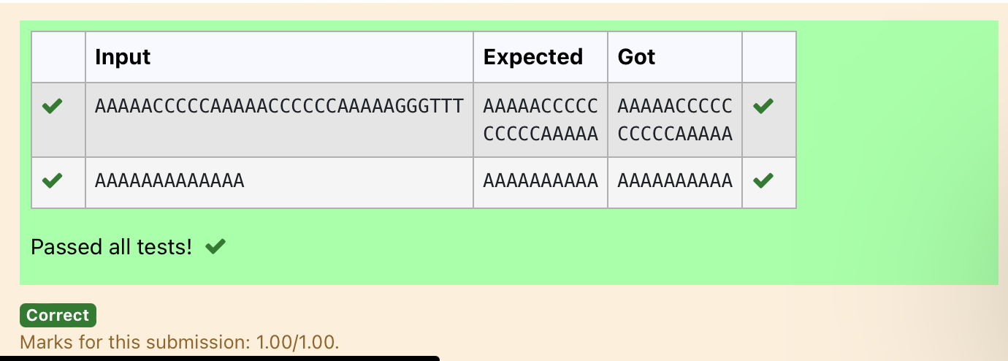

**Ex. No. : 8.4 Date: 15/5/24**

**Register No.: 231801176 Name: Susmitha.M**

**Print repeated no**

Given an array of integers nums containing n + 1 integers where each integer is in the range [1, n] inclusive.There is only **one repeated number** in nums, return *this repeated number*. Solve the problem using [set](http://118.185.187.137/moodle/mod/resource/view.php?id=734).

**Example 1:**

**Input:** nums = [1,3,4,2,2]

**Output:** 2

**Example 2:**

**Input:** nums = [3,1,3,4,2]

**Output:** 3

**For example:**

|  |  |
| --- | --- |
| **Input** | **Result** |
| 1 3 4 4 2 | 4 |

# Program:

n =input().split(" ") n = list(n)

for i in range(len(n)):

for j in range(i+1,len(n)): if n[i] == n[j]:

print(n[i]) exit(0)

# Output:

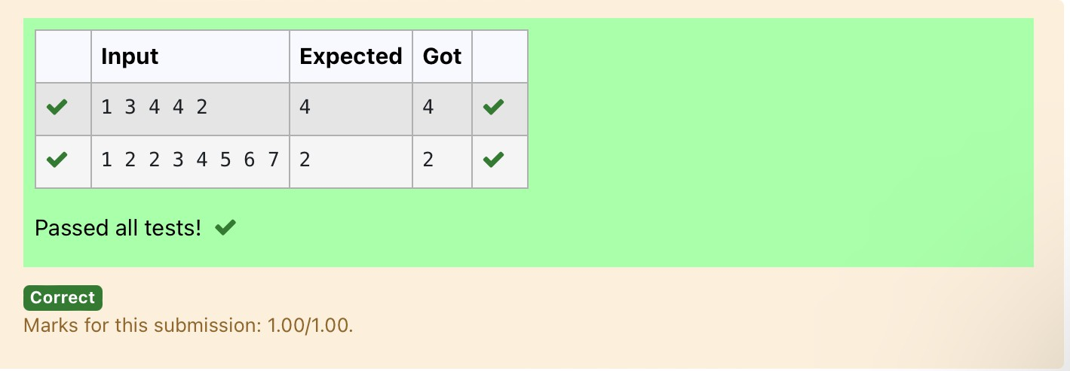

**Ex. No. : 8.5 Date: 15/5/24**

**Register No.: 231801176 Name: Susmitha.M**

**Remove repeated**

Write a program to eliminate the common elements in the given 2 arrays and print only the non-repeating elements and the total number of such non-repeating elements.

Input Format:

The first line contains space-separated values, denoting the size of the two arrays in integer format respectively.

The next two lines contain the space-separated integer arrays to be compared.

[Sample](https://www.rajalakshmicolleges.net/moodle/mod/quiz/view.php?id=5127) Input:

5 4

1 2 8 6 5

2 6 8 10

[Sample](https://www.rajalakshmicolleges.net/moodle/mod/quiz/view.php?id=5127) Output:

1 5 10

3

[Sample](https://www.rajalakshmicolleges.net/moodle/mod/quiz/view.php?id=5127) Input:

5 5

1 2 3 4 5

1 2 3 4 5

[Sample](https://www.rajalakshmicolleges.net/moodle/mod/quiz/view.php?id=5127) Output:

NO SUCH ELEMENTS

**For example:**

|  |  |
| --- | --- |
| **Input** | **Result** |
| 5 4  1 2 8 6 5  2 6 8 10 | 1 5 10  3 |

# Program:

a=input() d=[]

b=input() c=input()

b=tuple(b.split(" "))

c=tuple(c.split(" ")) for i in b:

if i not in c: d.append(i)

for i in c:

if i not in b: d.append(i)

for i in range(len(d)): print(int(d[i]),end=' ')

print() print(len(d))

# Output:

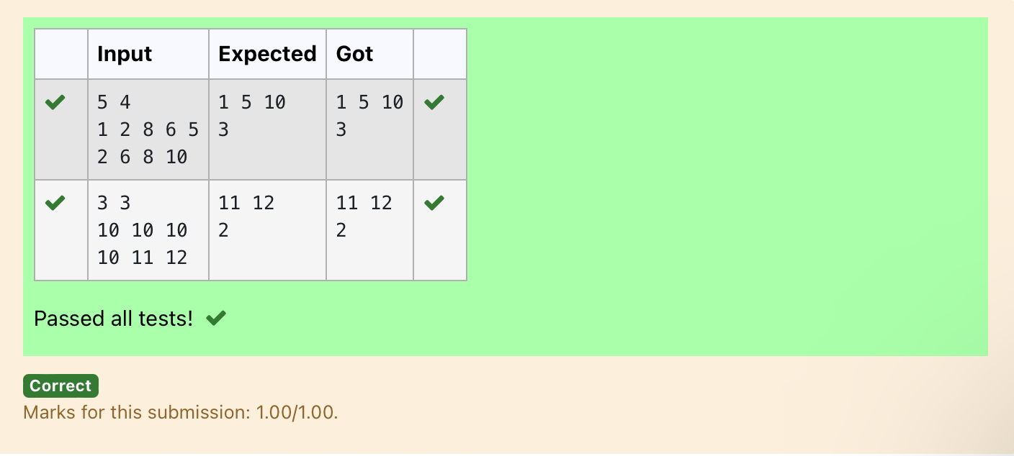

**Ex. No. : 8.6 Date: 15/5/24**

**Register No.: 231801176 Name: Susmitha.M**

**Malfunctioning Keyboard**

There is a malfunctioning keyboard where some letter keys do not work. All other keys on the keyboard work properly.

Given a string text of words separated by a single space (no leading or trailing spaces) and a string brokenLetters of all distinct letter keys that are broken, return the number of words in text you can fully type using this keyboard.

Example 1:

Input: text = "hello world", brokenLetters = "ad" Output:

1

Explanation: We cannot type "world" because the 'd' key is broken.

**For example:**

|  |  |
| --- | --- |
| **Input** | **Result** |
| hello world ad | 1 |

Program: **a=input() b=input() c=set()**

**for i in a: for j in b:**

**if j in i:**

**c.add(i)**

**print(len(c))**

# Output:

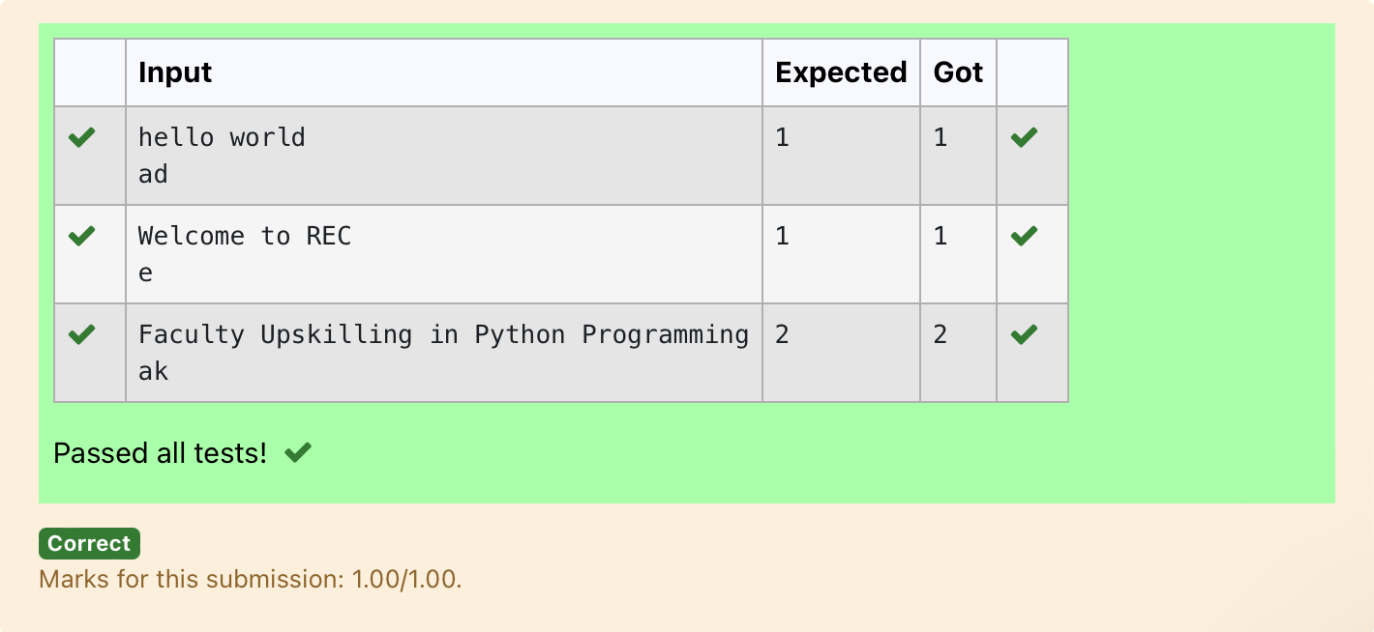

**Ex. No. : 8.7 Date: 15/5/24**

**Register No.: 231801176 Name: Susmitha.M**

**American keyboard**

Given an array of strings words, return *the words that can be typed using letters of the alphabet on only one row of American keyboard like the image below*.

In the **American keyboard**:

* the first row consists of the characters "qwertyuiop",
* the second row consists of the characters "asdfghjkl", and
* the third row consists of the characters "zxcvbnm"

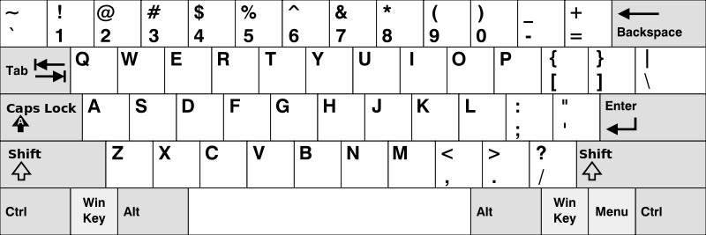

**Example 1:**

**Input:** words = ["Hello","Alaska","Dad","Peace"]

**Output:** ["Alaska","Dad"]

**Example 2:**

**Input:** words = ["omk"]

**Output:** []

**Example 3:**

**Input:** words = ["adsdf","sfd"]

**Output:** ["adsdf","sfd"]

**For example:**

|  |  |
| --- | --- |
| **Input** | **Result** |
| 4  Hello Alaska Dad Peace | Alaska Dad |

# Program:

**def findWords(words): row1 = set('qwertyuiop') row2 = set('asdfghjkl') row3 = set('zxcvbnm')**

**result = []**

**for word in words:**

**w = set(word.lower())**

**if w.issubset(row1) or w.issubset(row2) or w.issubset(row3): result.append(word)**

**if len(result) == 0: print("No words")**

**else:**

**for i in result: print(i)**

**a = int(input())**

**arr = [input() for i in range(a)] findWords(arr)**

Output:

